**Workshop 2 : Leadership skills required for professional effectiveness**

**Pr khawla KHOUMSSI**

ENSA, USMBA, Fès



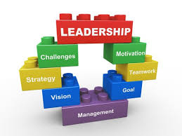

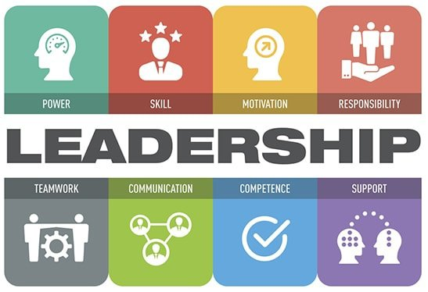

Entrepreneurial skills embrace a broad vary of varied skillsets like technical skills, leadership and business management skills and artistic thinking. As a result, entrepreneurial skills are often applied to several totally different job roles and industries, developing your entrepreneurial abilities will mean developing many varieties of skills.

The objective of this workshop is to make the student engineer aware of the importance of leadership skills for greater effectiveness in the workplace, including :

* Active listening and empathy,
* Clear communication and the ability to mobilise staff,
* Strategic thinking and foresight,
* Creativity and innovation,
* The ability to inspire and convince others.
* Flexibility and agility,
* Delegation and team spirit, …

Mots clés : Leagership, Leadership skills, professional effectiveness, operational performance.



**ENSAF**

**JEPI#2**



## JEPI#2 : *Un futur ingénieur, déjà entrepreneur*